REGRESSION ANALYSIS
Regression analysis is used to identify determinants that impact on a potential variable of choice. The main use of Regression is to develop a relationship between X and Y, which can be used to generate forecasts of Y in the future based on given values of X.
When we have 1 X involved with Y >> Univariate Analysis
When we have more than 1X used to forecast Y >> Multivariate Analysis
- PRE-REQUISITES
PR1: is to have a strong correlation between variables under study
PR2: identify the main variable of study (variable to be explained) and the explanatory variables (independent variables)
In other terms, the Y variable is always the one you want to explain or forecast
Whilst the X variables, are those used to explain changes in the main variable
For example, if you want to forecast exchange rates (Y), your potential explanatory variables:
X1 = interest rates
X2 = inflation rates
X3 = oil prices
In our seminar (Y = coassets) and our Xs are:
X1= invturn
X2= opincgth
X3= salesgth
X4= capgth
X5 = opincrat
X6 = retasset
X7=indsgth

We select Pearson’s correlation because this applies in social sciences; in other terms we are testing the following: TEST OF CORRELATION
$H_{0}$: Correlation = 0
$H_{1}$: Correlation ≠ 0

Decision rule is to reject $H_{0}$ if the significance of the correlation test is less than 0.05 (5%). According to SPSS, the default is to run a two-tailed test.
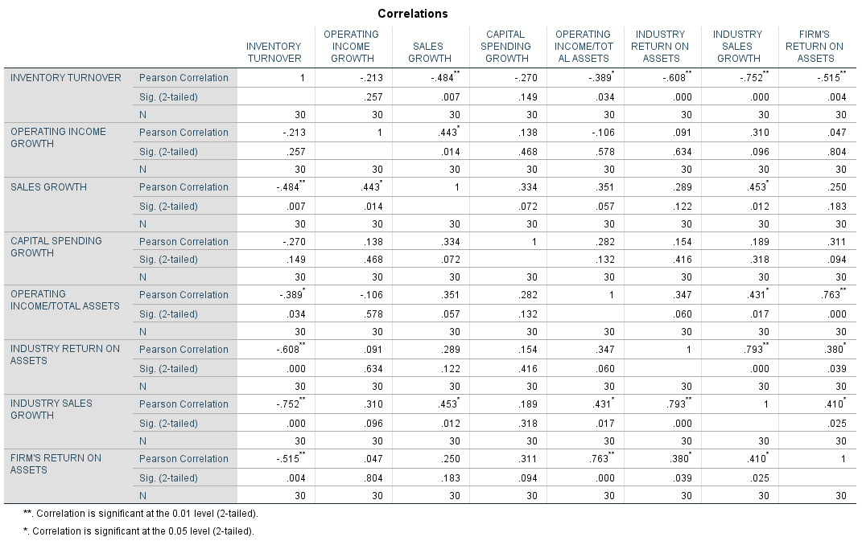

According to the correlation table, coassets seem to be correlated with four different variables:
- Inventory turnover
- Operating income / TA
- Industry return on assets
- Industry sales growth

Correlation examines the existence of relationship between two variables (BIVARIATE); Regression quantifies and used this relationship for forecasting purposes. Hence, the importance of establishing the existence of a correlation relationship before cracking on with the Regression exercise.

- PROCESS
The aim here is to generate a linear equation of the type:
Y = a + bx
Where,
Y = dependent variable
A = intercept (constant)
B = gradient (slope)
X = dependent variable

In this example we will forecast “COASSETS” (FIRMS RETURN ON ASSETS) using the explanatory variable “OPINCRAT” (OPERATING INCOME / TA)
Therefore, the REGRESSION EQUATION is:
COASSETS = β₀ + β₁ * OPINCRAT + µ

Step 1:
Click Analyze > Regression > Linear... on the top menu, as shown below:
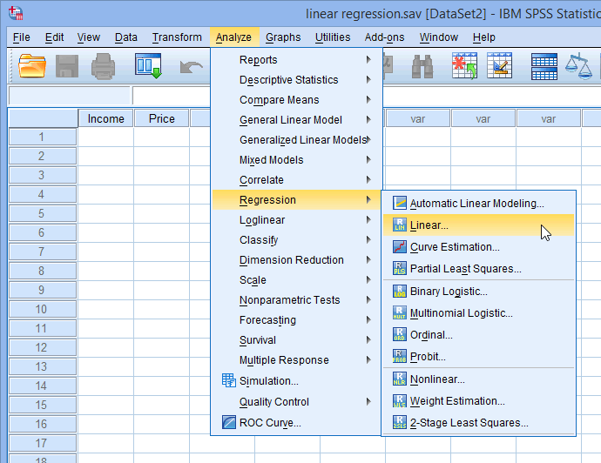

Step 2:
Transfer the independent variable, OPINCRAT into the Independent(s): box and the dependent variable, COASSETS , into the Dependent: box. You can do this by either drag-and-dropping the variables or by using the appropriate buttons. You will end up with the following screen

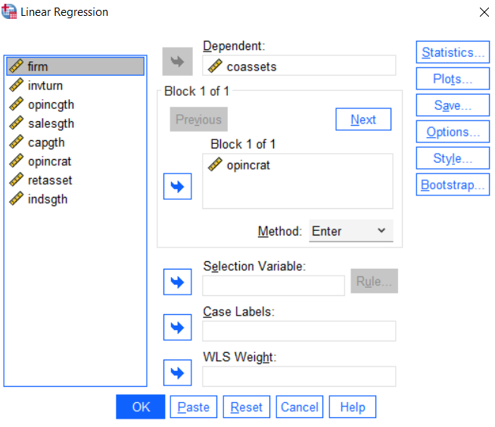

Step 3
Click on the OK button. This will generate the results.

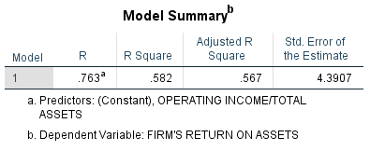

R = 0.763 (coefficient of correlation)
This coefficient shows a relatively strong positive correlation between COASSETS (FIRMS RETURN ON ASSETS) and OPINCRAT (OPERATING INCOME / TA)
R^2 = 0.582 (Coefficient of determination)
58.2% of changes in the main variable (COASSETS) are due to a linear relationship with the explanatory variable (OPINCRAT). The rest (41.8%) is due to extraneous factors not included in this regression model.
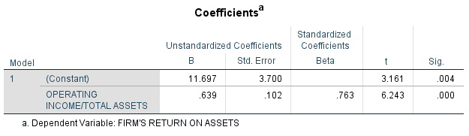
Y = B + A * X
COASSETS = 11.967 + 0.639 * (REGRESSION EQUATION)
Interpretation of the Regression equation:
- There is no meaningful interpretation for the intercept
- For each one unit increase in X (OPINCRAT), COASSETS increases by 0.639 units

